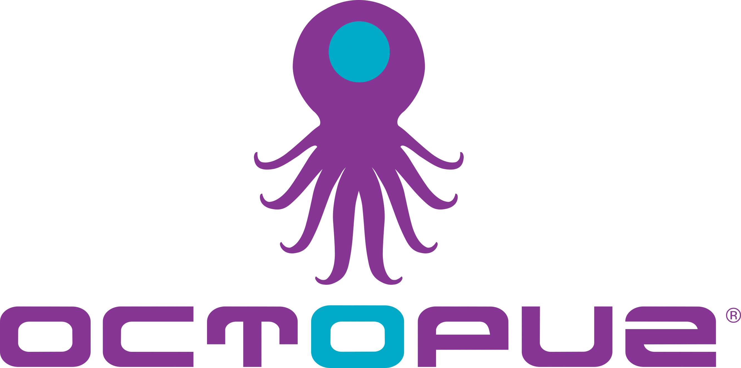
For release on October 31st, 2019

OCTOPUZ Inc. showcasing latest OCTOPUZ 2.3 release at FABTECH
Visit OCTOPUZ in Hall B2, Booth #B23113 and discover the latest advancement to the industry-defining OLRP software

Waterloo, ON: In November, OCTOPUZ Inc. will be releasing their latest software update, OCTOPUZ 2.3, and will be available for demonstration at FABTECH 2019. Visitors to the event, which runs from November 11th to November 14th in Chicago, IL, will experience the Offline Robot Programming (OLRP) software in action and be amongst the first to see how OCTOPUZ 2.3 continues to redefine the standards in OLRP by simplifying solving toolpath trajectories.

The software now enables users to automatically create and optimize circular toolpaths. The new Circularize Path tool gives users the ability to create circular movements within a path statement, which can greatly reduce the total number of program points required for a robot to perform its desired motion.

Advanced path programming tools give users more power and control to command paths and individual points. The new Surfacing tool automatically creates toolpaths that follow an entire surface with only a few buttons clicks, while PathFinder can now automatically solve for multiturn errors, reducing the time and effort required to touch-up issue points manually.

Several enhancements to the PathImporter tool, which include support for DXF files, also provide an improved user experience when importing CAM paths into the software.

The OCTOPUZ team will be on hand to give visitors live, customized demonstrations of the full offline robot programming and simulation capabilities with a walkthrough of how the OCTOPUZ solution works start-to-finish to solve unique challenges for various fabrications applications in the robotics industry.

Connect with OCTOPUZ at FABTECH from November 11th to November 14th in Hall B2, Booth #B23113 and be amongst the first to experience the latest features of the leading Offline Robot Programming software.

-----

If you would like more information on this topic, please call +1 (519) 496-5376 or email info@octopuz.com

For more on OCTOPUZ 2.3, visit:
www.OCTOPUZ.com/offline-robot-programming-software/octopuz-2-3/

